- A software company developed a set of sales management system for a shopping mall. When analyzing and designing the system, the developers found that it was often necessary to traverse the commodity data and customer data in the system. Please use iterator mode to design the sales management system.The UML diagram of the pattern is as follows:
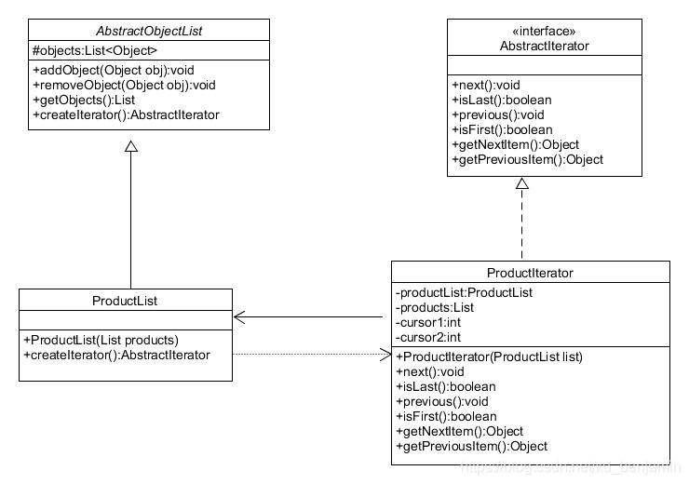
The method and description are shown in the table below:
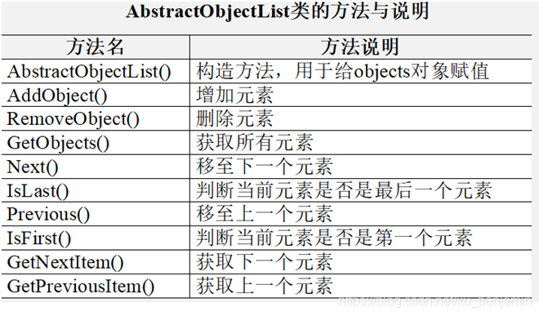

- Suppose we are developing a music playlist application. The application has a playlist that contains multiple music tracks. We want to implement the functionality to iterate over the tracks in the playlist, allowing users to play each track one by one, skip tracks, and get the current track information. The playlist has three main components: the MusicPlaylist class which manages the collection of tracks, the Track class representing each individual music track with properties like title, artist, and duration, and the MusicPlaylistIterator class which is the iterator for traversing the playlist. The client program is named PlaylistTester.
（Hint：The MusicPlaylistIterator should provide methods such as hasNext() to check if there is a next track, next() to move to the next track and return it, and reset() to start the iteration from the beginning. The MusicPlaylist class should have methods to add tracks and get the iterator.）

